Change Request - Tile the Porch Area
Project name: Flooring Renovation Project | Date: 07/11/2024
Change Requestor: David George | Change No: #1
Change Category (Check all that apply):
□ Schedule Cost Scope Requirements/Deliverables

Testing/Quality □ Resources

Does this Change Affect (Check all that apply):
□ Corrective Action □ Preventative Action □ Defect Repair Updates

□ Other
Change Being Requested:
- Tile the Porch Area
Reason for the Change:
- Enhance aesthetic appeal and functionality
- Maintain the porch area new and clean
Alternatives Considered:
- NA

Technical Changes Required to Implement this Change:
- Order Additional Tiles
- Order Equipment and Utilities
- Add Additional Resource

Describe Risks to be Considered for this Change:
- Extend the Delivery time
- Additional Cost
- Tile mismatch

Estimate Costs Needed to Implement this Change:

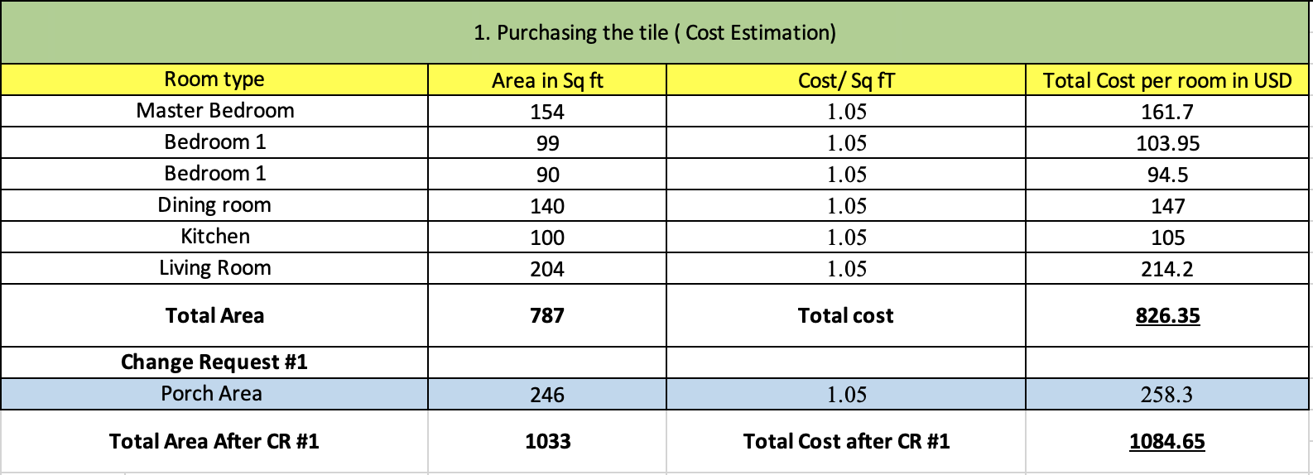

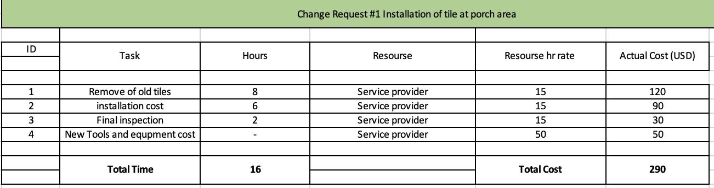

- The additional cost to install the tile at porch area is - $ 548.3
- The additional time to deliver the requested Change - 16hrs = 2 days (considering 8hr per day)

Describe the Implications to Quality:

A detailed inspection is carried out to check bumps, gaps, and alignment between tiles to ensure its appearance and function to meet customer satisfaction.

Disposition:
□ Approve □ Reject □ Defer
Signature: D.A George

X _________________________

